## 1.INTRODUCTION

* As the population increases cleanliness also decreases. In the metropolitan city more diseases have spread the problem of garbage waste.
* The development of smart cities needs a smart garbage monitoring system.
* So, the garbage waste management system plays a major problem in the global world. The garbage monitoring system is succeeding with smart bins.
* We develop smart bins, and it is connected to the dashboard and it can be accessed anywhere.
* Our smart bins are implemented using IoT, cloud technology and data science.
* For domestic care purposes, we separate or more precisely segregate the waste into two types wet and dry waste.
* Segregating the waste and collection level helps in reducing the operational cost at the disposal and reusing time.
* Based on the moisture content present in the waste.
* IoT is used for hardware progress on the devices and cloud is used for storing the data.

## 1.1 Motivation :

* We can keep ourselves clean and maintain our environment tidy plays a major role on making our country healthy and wealthy.
* This project helps to clean the garbage as soon as possible when it is nearing the fulfillment of the garbage bin.
* This prevents the diseases arise due to waste dumping and increases cleanliness of the city. This makes very miserable for India to become Swach Bharat.

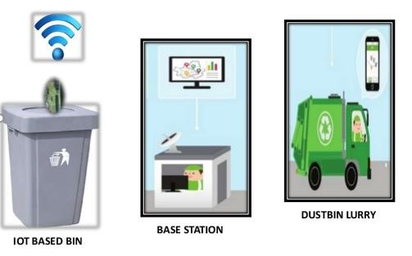

**Figure:** Motive of Project

**1.2 OVERVIEW:**

* + - In the present scenario, as the population is increasing day by day,
    - The environment should be clean and hygienic.
    - Dumping garbage in public places creates a polluted environment in the neighborhood.
    - Overloaded garbage bins create unhygienic conditions for people as well as ugliness to that place leaving bad smell.
    - It could cause several serious diseases to the people living around.
    - People are suffering by lung diseases. Such as CACOSMIA**.**
    - It causes a persistent feeling of smelling something unpleasant.
    - To reduce waste and maintain good hygiene, we need a systematic approach to tackle the problem.
    - To avoid all such situations, we are going to implement a project called IoT Based Smart Garbage Monitoring system and Domestic Care.

## 1.3 PROBLEM AND STATEMENT:

* + - We are living in the aera of Smart cities where everything is planned and systematic.
    - The problem we are facing is of the population, which is rising rapidly.
    - In recent years, urban migration has skyrocketed. This has resulted in the rise of garbage waste everywhere.
    - Dumping garbage in public places creates a polluted environment in the neighborhood.
    - It could cause several serious diseases in the people living around.
    - This will disrupt the evaluation of the affected area.
    - To reduce waste and maintain good hygiene, we need a systematic approach to tackle the problem.
    - We propose a solution to this waste problem which manages the garbage waste smartly.
    - We propose an IoT based smart system based on clean waste management that assesses the level of waste on dustbins through sensory systems.

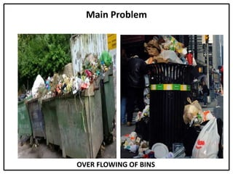

## 1.4 PROPOSED AREA:

* + - There are functional components in the system. They are……
      * Automatic Dry & Wet Waste Segregating.
      * Live Monitoring system.
      * We can access it from anywhere.
      * We can generate annual reports of garbage waste.
    - The purpose of the project is to help manage waste management in urban and rural areas.
    - Project focuses on the Garbage Monitoring System using an ultrasonic sensor as a distance measurement sensor.
    - Arduino board is programmed using the Arduino IDE software.
    - Moisture sensors detect the moisture content in the garbage or waste.
    - GSM Module is connected to the devices, which helps for live monitoring.
    - It is connected to the person who is monitoring and Dustbin.

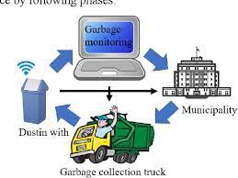

## 1.5 AIM OF THE PROJECT:

* + - The purpose of the project is to help manage waste management in urban and rural areas.
    - This project introduces the design and implementation of garbage monitoring by measuring the garbage level in real time and alerting the municipality whenever the bin is full.
    - To separate or more precisely segregate the waste into two types wet and dry waste, based on the moisture content present in the waste.
    - Segregating the waste and collection level helps in reducing the operational cost at the disposal and reusing time.
    - The system shows the status of garbage bin levels in a website from the sensor data and sends a notification to mobile whenever a bin is full.
    - So that the waste can be collected. This bin data is also saved to a database for further analysis.

## 2.LITERATURE OVERVIEW

* 1. **Garbage and Street Light Monitoring System Using Internet of Things:**
     + In solid waste bin monitoring system garbage bin set the public place then Camera set for garbage bin location.
     + The camera captured images of garbage bins. Radio Frequency Identification (RFID), GPS and GIS send images for workstation.
     + The RFID reader and camera are mounted in the truck, when truck comes closer to the bin RFID reader communicated RFID tag. & send all the information.
     + The System is used to control Hut. This Controlling Hut is SMS Technology.
     + The GPS and GPRS mapping server to analyze data of various locations.
     + The control station compiled all the information and stored in the system database.
     + The bin status and waste truck were monitored.

## Waste Bin Monitoring System Using Integrated Technologies:

* + - In waste bin monitoring system using ZigBee and Global mobile communication system (GSM).
    - The sensors are placed in the common garbage bins placed at the public place when the garbage reaches the level of the sensors.
    - Then that indicated will give indication to the driver by ARM7 they sending SMS using GSM technology.
    - The technology is used by Zigbee, Global mobile system (GSM), ARM 7 Controller. The range of communication of the ZigBee is almost 50 meters.
    - They use for range GSM Module, analyzing the image we get an idea about level of garbage.
    - The ZigBee and GSM system would be able to monitor the solid waste collection process.
    - This technique overcomes some disadvantages which are use of minimum route, low cost, fuel use, clean environment.

**2.3** **An Overview for Solid Waste Bin Monitoring System:**

* The waste management is built around several element. Waste item, domestic bin, trash bags, collective containers and collecting vehicles.
* The waste flow starts from the waste item and the domestic bin to end in the collecting vehicles. Use the waste identification for sorting process.
* Base on RFID technology new trash bag is added in a collective container. The technology use Radio Frequency Identification (RFID), Smart vehicular and Trash Bag.
* They only identify RFID tags garbage bins, Low data speed, high cost. The ZigBee and GSM system would be able to monitor the solid waste collection process.
* This technique overcome some disadvantages which are use of minimum route, low cost, fuel use, clean environment.

## 2.4 Smart Dustbin:

* + - A single directional cylinder is suspended next to the lid of dustbin.
    - The piston is free to move up and down vertically inside the dustbin to a certain level.
    - A plate is attached to the cylinder for compressing the garbage.
    - The shape of this plate depends upon the shape of the dustbin.
    - The compressing plate consists of a side hole through which the leaf switch is suspended upside down. Technology uses Piston, Switch, microcontroller, the single directional cylinder, smart dustbin.
    - Only use for smart dustbins, they are not providing garbage collection.
    - Smart Dustbins can prevent the accumulation of garbage along the roadside to a great extent thereby controlling the widespread of many diseases.
    - It can prevent pollution and prevent the consumption of the spread-out garbage by the street animals.

## 3.EXPERIMENTAL INVESTIGATION

## Embedded system implementation:

* + - An embedded system is one kind of computer system mainly designed to perform several tasks like to access, process, and store and control the data in various electronics-based systems.
    - Embedded systems are a combination of hardware and software where software is usually known as firmware that is embedded into the hardware.
    - One of its most important characteristics of these systems is, it gives the o/p within the time limits.
    - Embedded systems support to make the work more perfect and convenient. So, we frequently use embedded systems in simple and complex devices too.
    - The applications of embedded systems mainly involve in our real life for several devices like microwave, calculators, TV remote control, home security and neighborhood traffic control systems, etc.

User interface

Embedded system

Hardware

Software

Inputs

Output

Link to other systems

**Fig3.1: Overview of embedded system**

## EXISTING SYSTEMS:

* + - In the existing system, garbage bins are manually managed, and it needs human effort to check every time.
    - Monitoring and management of waste is one of the primary issues in the cities.

### Draw backs of the system:

* It sends messages only when bin is filled.
* There is no monitoring presented.
* Time consuming and less effective
* it purely depends upon only weight.
* high costs
* bad smell spreads and may cause illness to human beings.

## PROPOSED SYSTEM:

* In the proposed system we have automated this process. Here we are using Ultrasonic sensor to check whether the bins are full or not.
* When waste is filled in the bins the distance will be decreased between the waste and sensors. Every time it will check the level and calculate the distance.
* This live data is sent to Arduino. Arduino will process the data and send it to the cloud server through GSM/GPRS.
* IR sensor will detect whether a person through waste or not. soil moisture sensor will detect the waste is dry or wet based on it the waste will segregate.
* Through this webpage the user can access the data and plan according to that, which bin needs attention and certain action will be taken to clean the bins.

**Block Diagram:**

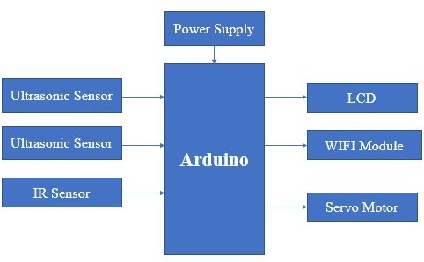

## Fig3.3: Layout of proposed system

**4.HARDWARE REQUIREMENTS**

## 4.1ARDUINO:

* + - The Arduino microcontroller is an easy to use yet powerful single board computer that has gained considerable traction in the hobby and professional market.
    - Arduino is open source, which means hardware is reasonably priced and development software is free.
    - This guide is for students in ME 2011, or students anywhere who are confronting the Arduino for the first time. For advanced Arduino users, prowl the web; there are lots of resources.
    - 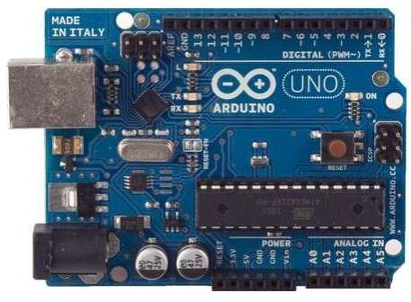This is what the Arduino board looks like.

#### Fig 4.1: Arduino

* The Arduino programming language is a simplified version of C/C++. If you know C, programming the Arduino will be familiar. If you do not know C, no need to worry as only a few commands are needed to perform useful functions.
* Programming to “Node MCU ESP32’ using ARDUINO IDE software.Using code in C/C++ Language

#### 4.1.1 Arduino Hardware:

* + - The power of the Arduino is not its ability to crunch code, but rather its ability to interact with the outside world through its input-output (I/O) pins.
    - The Arduino has 14 digital I/O pins labeled 0 to 13 that can be used to turn motors and lights on and off and read the state of switches.
    - Each digital pin can sink or source about 40 mA of current. This is more than adequate for interfacing most devices but does mean that interface circuits are needed to control devices other than simple LED's.
    - In other words, you cannot run a motor directly using the current available from an Arduino pin, but rather must have the pin drive an interface circuit that in turn drives the motor.
    - To interact with the outside world, the program sets digital pins to a high or low value using C code instructions, which corresponds to +5 V or 0 V at the pin.
    - The pin is connected to external interface electronics and then to the device being switched on and off. To interact with the outside world, the program sets digital pins to a high or low value using C code instructions.
    - which corresponds to +5 V or 0 V at the pin. The pin is connected to external interface electronics and then to the device being switched on and off. The sequence of events is shown in this figure.

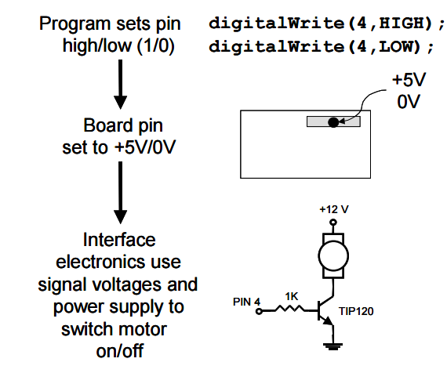

* To determine the state of switches and other sensors, the Arduino can read the voltage value applied to its pins as a binary number.
* The interface circuitry translates the sensor signal into a 0 or +5 V signal applied to the digital I/O pin. Through a program command, the Ardiomp interrogates the state of the pin.
* If the pin is at 0 V, the program will read it as a 0 or LOW. If it is at +5 V, the program will read it as a 1 or HIGH. If more than +5 V is applied, you may blow out your board, so be careful.
* The sequence of events to read a pin is shown in this figure.

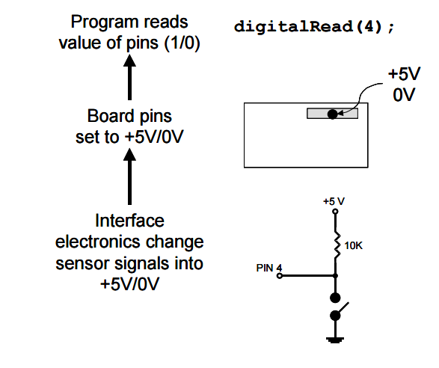

* Interacting with the world has two sides. First, the designer must create electronic interface circuits that allow motors and other devices to be controlled by a low (1-10 mA) current signal that switches between 0 and 5 V.
* other circuits that convert sensor readings into a switched 0 or 5 V signal. Second, the designer must write a program using the set of Arduino commands that set and read the I/O pins. Examples of both can be found in the Arduino resources section of the ME2011 web site.

**4.1.2 Atmega328p features:**

* High Performance, Low Power AVR® 8-Bit Microcontroller
* Advanced RISC Architecture

– 131 Powerful Instructions

– Most Single Clock Cycle Execution

– 32 x 8 General Purpose Working Registers

– Fully Static Operation

– Up to 20 MIPS Throughput at 20 MHz

– On-chip 2-cycle Multiplier

* High Endurance Non-volatile Memory Segments

– 4/8/16/32K Bytes of In-System Self-Programmable Flash program memory

(ATmega48PA/88PA/168PA/328P)

– 256/512/512/1K Bytes EEPROM (ATmega48PA/88PA/168PA/328P)

– 512/1K/1K/2K Bytes Internal SRAM (ATmega48PA/88PA/168PA/328P)

– Write/Erase Cycles: 10,000 Flash/100,000 EEPROM

– Data retention: 20 years at 85°C/100 years at 25°C(1)

– Optional Boot Code Section with Independent Lock Bits In-System Programming

by On-chip Boot Program True Read-While-Write Operation

– Programming Lock for Software Security

* Peripheral Features

– Two 8-bit Timer/Counters with Separate Prescaler and Compare Mode

– One 16-bit Timer/Counter with Separate Prescaler, Compare Mode, and Capture

Mode

– Real Time Counter with Separate Oscillator

– Six PWM Channels – 8-channel 10-bit ADC in TQFP and QFN/MLF package

Temperature Measurement – 6-channel 10-bit ADC in PDIP Package Temperature

Measurement

– Programmable Serial USART

– Master/Slave SPI Serial Interface

– Byte-oriented 2-wire Serial Interface (Philips I2 C compatible)

– Programmable Watchdog Timer with Separate On-chip Oscillator

– On-chip Analog Comparator

– Interrupt and Wake-up on Pin Change

* Special Microcontroller Features

– Power-on Reset and Programmable Brown-out Detection

– Internal Calibrated Oscillator

– External and Internal Interrupt Sources

– Six Sleep Modes: Idle, ADC Noise Reduction, Power-save, Power-down, Standby,

and Extended Standby

* I/O and Packages

– 23 Programmable I/O Lines

– 28-pin PDIP, 32-lead TQFP, 28-pad QFN/MLF and 32-pad QFN/MLF

* Operating Voltage:

– 1.8 - 5.5V for ATmega48PA/88PA/168PA/328P

* Temperature Range:

– -40°C to 85°C

* Speed Grade:

– 0 - 20 MHz @ 1.8 - 5.5V

* Low Power Consumption at 1 MHz, 1.8V, 25°C for ATmega48PA/88PA/168PA/328P:

– Active Mode: 0.2 mA

– Power-down Mode: 0.1 µA

– Power-save Mode: 0.75 µA (Including 32 kHz RTC)

**4.1.3 PIN CONFIGURATIONS**

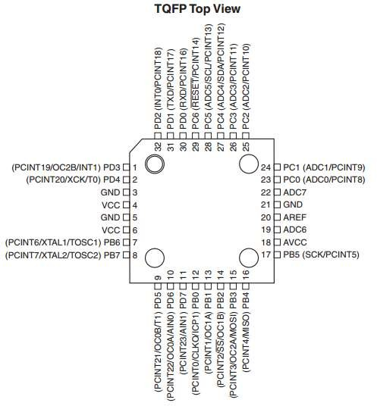

#### Fig 4.2: PINS CONFIGURATIONS

**4.1.4 Pin Descriptions:**

* + - **VCC:** Digital supply voltage.
    - **GND:** Ground.
    - **Port B (PB7:0) XTAL1/XTAL2/TOSC1/TOSC2:** Port B is an 8-bit bi-directional I/O port with internal pull-up resistors (selected for each bit). The Port B output buffers have symmetrical drive characteristics with both high sink and source capability.
    - **Port C (PC5:0):** Port C is a 7-bit bi-directional I/O port with internal pull-up resistors (selected for each bit). The PC5.0 output buffers have symmetrical drive characteristics with both high sink and source capability.
    - **PC6/RESET:** If the RSTDISBL Fuse is programmed, PC6 is used as an I/O pin. Note that the electrical characteristics of PC6 differ from those of the other pins of Port C. If the RSTDISBL Fuse is unprogrammed, PC6 is used as a Reset input.
    - **Port D (PD7:0):** Port D is an 8-bit bi-directional I/O port with internal pull-up resistors (selected for each bit). The Port D output buffers have symmetrical drive characteristics with both high sink and source capability. As inputs, Port D pins that are externally pulled low will source current if the pull-up resistors are activated. The Port D pins are tri-stated when a reset condition becomes active, even if the clock is not running.
    - **AVCC:** AVCC is the supply voltage pin for the A/D Converter, PC3:0, and ADC7:6. It should be externally connected to VCC, even if the ADC is not used. If the ADC is used, it should be connected to VCC through a low-pass filter. Note that PC6.4 use digital supply voltage, VCC.
    - **AREF:** AREF is the analog reference pin for the A/D Converter
    - **ADC7:6 (TQFP and QFN/MLF Package Only):** In the TQFP and QFN/MLF package, ADC7:6 serve as analog inputs to the A/D converter. These pins are powered from the analog supply and serve as 10-bit ADC channels.

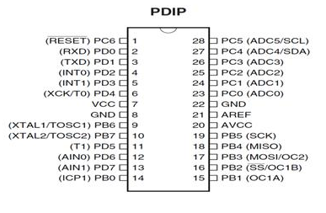

**Fig 4.3: PDIP PIN CONFIGURATION**

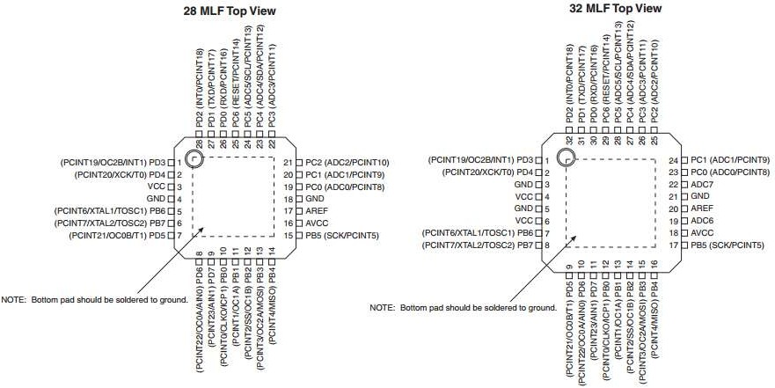

**FIG 4.4: MLF PIN CONFIGURATION**

## 4.2 IR SENSOR:

* + - An infrared sensor is an electronic device, which emits in order to sense some aspects of the surroundings.
    - An IR sensor can measure the heat of an object as well as detects the motion. These types of sensors measure only infrared radiation, rather than emitting it that is called as a passive IR sensor.
    - Usually in the infrared spectrum, all the objects radiate some form of thermal radiations. These types of radiations are invisible to our eyes, which can be detected by an infrared sensor.
    - The emitter is simply an IR LED (Light Emitting Diode) and the detector is simply an IR photodiode which is sensitive to IR light of the same wavelength as that emitted by the IR LED.
    - When IR light falls on the photodiode, the resistances, and these output voltages, change in proportion to the magnitude of the IR light received.

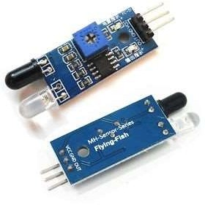

#### Fig 4.5: IR SENSOR

### 4.2.1 Different Types of IR Sensors and Their Applications:

IR sensors are classified into different types depending on the applications. Some of the typical applications of different [types of sensors](https://www.elprocus.com/types-of-sensors-with-circuits/) are:

* The speed sensor is used for synchronizing the speed of multiple motors.
* The [temperature sensor](https://www.elprocus.com/temperature-sensors-applications/) is used for industrial temperature control.
* [PIR sensor](https://www.elprocus.com/pir-sensor-basics-applications/) is used for automatic door opening system and
* [Ultrasonic sensor](https://www.elprocus.com/motion-detector-circuit-with-working-description-and-its-applications/) are used for distance measurement.

## Working Principle of Infrared Sensor: Infrared Sensors works on three fundamental Physics law.

* **Planck’s Radiation Law**: Any object whose temperature is not equal to absolute Zero (0 Kelvin) emits radiation.
* **Stephan Boltzmann Law**: The total energy emitted at all wavelengths by a black body is related to the absolute temperature.
* **Wein’s Displacement Law:** Objects of different temperature emit spectra that peak at different wavelengths that is inversely proportional to Temperature.
* **Key Elements of Infrared Detection System**: The key elements of Infrared Detection System are:

### IR Transmitter: IR Transmitter acts as source for IR radiation. According to Plank’s Radiation Law, every object is a source of IR radiation at temp T above 0 Kelvin. In most cases black body radiators, tungsten lamps, silicon carbide, infrared lasers, LEDs of infrared wavelength are used as sources.

### Transmission Medium: As the name suggests, Transmission Medium provides passage for the radiation to reach from IR Transmitter to IR Receiver. Vacuum, atmosphere, and optical fibers are used as medium.

### IR receiver: Generally, IR receivers are photo diode and photo transistors. They can detect infrared radiation. Hence IR receiver is also called as IR detector. Variety of receivers are available based on wavelength, voltage and package.IR Transmitter and Receivers are selected with matching parameters. Some of deciding specifications of receivers are photosensitivity or responsivity, noise equivalent power and detectivity.

### 4.2.2 How Infrared Sensor Works:

An Infrared Sensor works in the following sequence:

* IR source (transmitter) is used to emit radiation of required wavelength.
* This radiation reaches the object and is reflected.
* The reflected radiation is detected by the IR receiver.
* The IR Receiver detected radiation is then further processed based on its intensity. Generally, IR Receiver output is small, and amplifiers are used to amplify the detected signal.

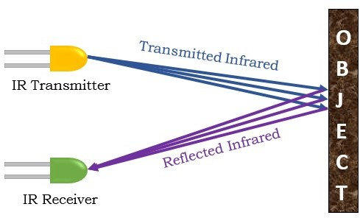

**Fig 4.6: How Infrared Sensor Works**

* IR sensors can be classified in two types based on presence of IR source.
* Active Infrared Sensor
  + Passive Infrared Sensor

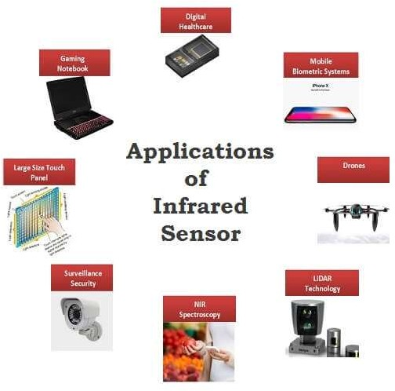

**Fig 4.7: Applications of Infrared Sensor**

**4.3 Ultrasonic sensor:**

* + - An ultrasonic sensor is an electronic device that measures the distance of a target object by emitting ultrasonic sound waves and converts the reflected sound into an electrical signal.
    - 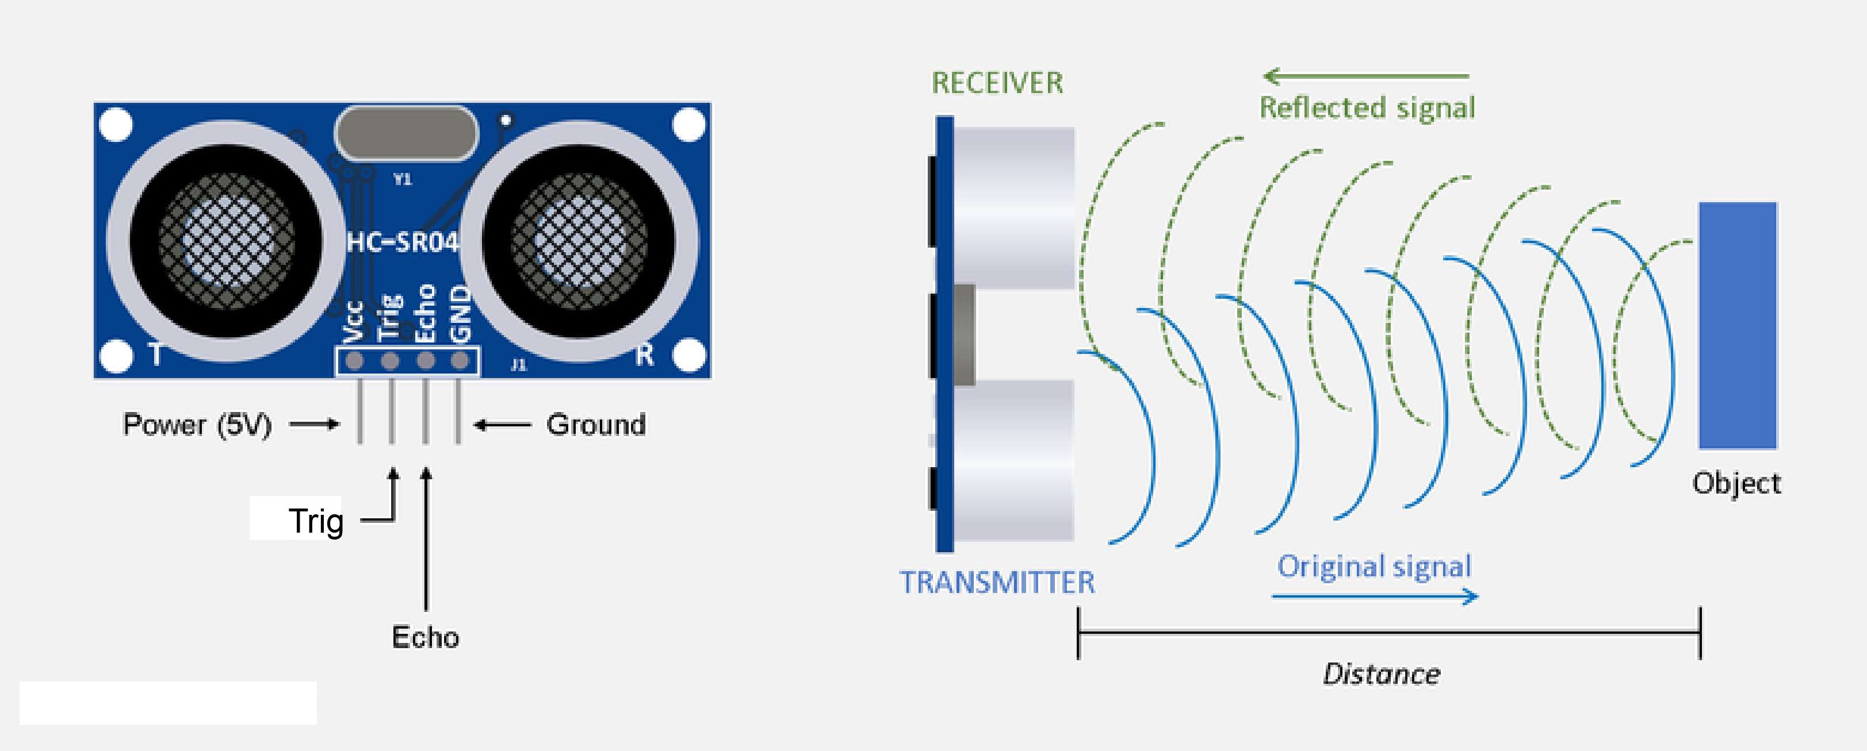Ultrasonic waves travel faster than the speed of audible sound (i.e., the sound that humans can hear). Ultrasonic sensors have two main components: the transmitter (which emits the sound using piezoelectric crystals) and the receiver (which encounters the sound after it has travelled to and from the target).

**Fig 4.8: ULTRASONIC SENSOR**

* To calculate the distance between the sensor and the object, the sensor measures the time it takes between the emission of the sound by the transmitter to its contact with the receiver.
* The formula for this calculation is D = ½ T x C (where D is the distance, T is the time, and C is the speed of sound ~ 343 meters/second).
* For example, if a scientist set up an ultrasonic sensor aimed at a box and it took 0.025 seconds for the sound to bounce back, the distance between the ultrasonic sensor and the box would be:

|  |
| --- |
| **D = 0.5 x 0.025 x 343** |

or about 4.2875 meters.

**4.3.1 HC-SR04 Sensor Features:**

* Operating voltage+5V
* Theoretical Measuring Distance: 2cm to 450cm
* Practical Measuring Distance: 2cm to 80cm.Accuracy: 3mm
* Measuring angle covered: <15°
* Operating Current: <15Ma.Operating Frequency: 40Hz

**4.3.2 HC-SR04 Ultrasonic Sensor – Working:**

As shown above the HC-SR04 Ultrasonic (US) sensor is a 4-pin module, whose pin names are Vcc, Trigger, Echo and Ground respectively.

* This sensor is a very popular sensor used in many applications were measuring distance or sensing objects are required.
* The module has two eyes like projects in the front which forms the Ultrasonic transmitter and Receiver. The sensor works with the simple high school formula that.

**Distance = Speed × Time**

* The Ultrasonic transmitter transmits an ultrasonic wave, this wave travels in air and when it gets objected by any material.
* it gets reflected toward the sensor this reflected wave is observed by the Ultrasonic receiver module as shown in the picture below.
* The Ultrasonic transmitter transmits an ultrasonic wave, this wave travels in air and when it gets objected by any material it gets reflected toward the sensor.
* to calculate the distance using the above formulae, we should know the Speed and time. Since we are using the Ultrasonic wave, we know the universal speed of US wave at room conditions which is 330m/s.
* The circuitry inbuilt on the module will calculate the time taken for the US wave to come back and turns on the echo pin high for that same amount of time, this way we can also know the time taken.
* Now simply calculate the distance using a microcontroller or microprocessor.

### 4.3.3 How to use the HC-SR04 Ultrasonic Sensor:

### **HC-SR04 distance** is commonly used with both microcontroller and microprocessor platforms like Arduino, ARM, PIC, Raspberry Pie etc. The following guide is universally since it must be followed irrespective of the type of computational device used.

### Power the Sensor using a regulated +5V through the Vcc ad Ground pins of the sensor. The current consumed by the sensor is less than 15mA and hence can be directly powered by the on board 5V pins (If available). The Trigger and the Echo pins are both I/O pins and hence they can be connected to I/O pins of the microcontroller.

### To start the measurement, the trigger pin has to be made high for 10uS and then turned off. This action will trigger an ultrasonic wave at frequency of 40Hz from the transmitter and the receiver will wait for the wave to return.

### Once the wave is returned after it is getting reflected by any object the Echo pin goes high for a particular amount of time which will be equal to the time taken for the wave to return back to the sensor.

### The amount of time during which the Echo pin stays high is measured by the MCU/MPU as it gives the information about the time taken for the wave to return back to the Sensor. Using this information, the distance is measured as explained in the above heading.

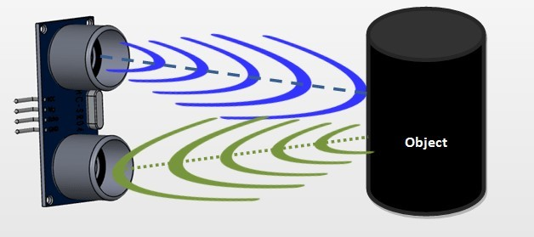

**Fig 4.9: TRANSMIT ULTRASONIC WAVES**

## 4.5 LCD:

* LCD (Liquid Crystal Display) is the innovation utilized in scratch pad shows and other littler PCs. Like innovation for light-producing diode (LED) and gas-plasma, LCDs permit presentations to be a lot slenderer than innovation for cathode beam tube (CRT).
  + - LCDs expend considerably less power than LED shows and gas shows since they work as opposed to emanating it on the guideline of blocking light.
    - A LCD is either made with an uninvolved lattice or a showcase network for dynamic framework show. Likewise alluded to as a meager film transistor (TFT) show is the dynamic framework LCD.
    - The uninvolved LCD lattice has a matrix of conductors at every crossing point of the network with pixels. Two conductors on the lattice send a current to control the light for any pixel.
    - A functioning framework has a transistor situated at every pixel crossing point, requiring less current to control the luminance of a pixel.
    - A 16x2 LCD show is an essential module that is generally utilized in various gadgets and circuits. These modules have more than seven sections and other multi fragment LEDs are liked.
    - The reasons being: LCDs are affordable, effectively programmable; have no restriction of showing exceptional and even custom characters (not at all like in seven fragments), movements, etc.
    - The reasons being: LCDs are affordable, effectively programmable; have no restriction of showing exceptional and even custom characters (not at all like in seven fragments), movements, etc.
    - A 16x2 LCD implies 16 characters can be shown per line and 2 such lines exist. Each character is shown in a lattice of 5x7 pixels in this LCD. There are two registers in this LCD, in particular Command and Data.
    - The directions given to the LCD are put away by the order register. An order is a direction given to LCD to play out a predefined assignment.
    - for example, introducing it, clearing its screen, setting the situation of the cursor, controlling presentation, and so forth. The information register will store the information that will be shown on the LCD.
    - The information is the character's ASCII incentive to show on the LCD.

**4.5.1 Data/Signals/Execution of LCD:**

* Now that was all about the signals and the hardware. Let us come to data, signals and execution.
* Two types of signals are accepted by LCD, one is data, and one is control. The LCD module recognizes these signals from the RS pin status. By pulling the R / W pin high, data can now also be read from the LCD display.
* Once the E pin has been pulsed, the LCD display reads and executes data at the falling edge of the pulse, the same for the transmission case.
* It takes 39-43μS for the LCD display to place a character or execute a command. It takes 1.53ms to 1.64ms except for clearing display and searching for cursor to the home position.
* Any attempt to send data before this interval may result in failure in some devices to read data or execute the current data. Some devices compensate for the speed by storing some temporary registers with incoming data.
* There are two RAMs for LCD displays, namely DDRAM and CGRAM. DDRAM registers the position in which the character would be displayed in the ASCII chart. Each DDRAM byte represents every single position on the display of the LCD.
* The DDRAM information is read by the LCD controller and displayed on the LCD screen. CGRAM enables users to define their personalized characters. Address space is reserved for users for the first 16 ASCII characters.

**Images of LCD Display: -**

[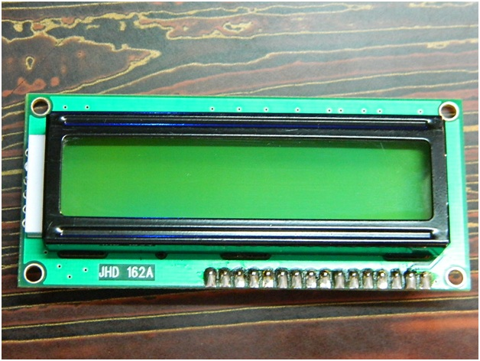](http://www.circuitstoday.com/wp-content/uploads/2012/02/LCD-Display-Front-Side.jpg)

**FIG 4.10: LCD – Front View**

#### 

#### Pin Diagram:

#### 

**Fig 4.11: LCD BACK VIEW**

* **RS (Register select):** A 16X2 LCD has two order and information registers. The determination of the register is utilized to change starting with one register then onto the next. RS=0 for the register of directions, while RS=1 for the register of information.
* **Command Register:** He guidelines given to the LCD are put away by the direction register. An order is a direction given to LCD to play out a predefined assignment, for example, instating it, clearing its screen, setting the situation of the cursor, controlling showcase, and so on. Order preparing happens in the direction register.
* **Data Register:** The information register will store the information that will be shown on the LCD. The information is the character's ASCII incentive to show on the LCD. It goes to the information register and is prepared there when we send information to the LCD. While choosing RS=1, the information register..

#### 4.5.2 LCD Commands:

There are some preset commands in the LCD that we need to send to the LCD via some microcontroller. The following are some important command instructions:

**TABLE -1**

|  |  |  |
| --- | --- | --- |
| **Sr. No.** | **Hex Code** | **Command to LCD instruction Register** |
| 1 | 01 | Clear display screen |
| 2 | 02 | Return home |
| 3 | 04 | Decrement cursor (shift cursor to left) |
| 4 | 06 | Increment cursor (shift cursor to right) |
| 5 | 05 | Shift display right |
| 6 | 07 | Shift display left |
| 7 | 08 | Display off, cursor off |
| 8 | 0A | Display off, cursor on |
| 9 | 0C | Display on, cursor off |
| 10 | 0E | Display on, cursor blinking |

**TABLE -2**

|  |  |  |
| --- | --- | --- |
| Pin  No | Function | Name |
| 1 | Ground (0V) | Ground |
| 2 | Supply voltage; 5V (4.7V – 5.3V) | Vcc |
| 3 | Contrast adjustment; through a variable resistor | VEE |
| 4 | Selects command register when low; and data register when high | Register Select |
| 5 | Low to write to the register; High to read from the register | Read/write |
| 6 | Sends data to data pins when a high to low pulse is given | Enable |
| 7 | 8-bit data pins | DB0 |
| 8 | DB1 |
| 9 | DB2 |
| 10 | DB3 |
| 11 | DB4 |
| 12 | DB5 |
| 13 | DB6 |
| 14 | DB7 |
| 15 | Backlight VCC (5V) | Led+ |
| 16 | Backlight Ground (0V) | Led- |

**Block Diagram of LCD Display: -**

**[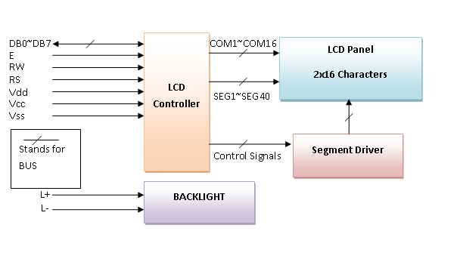](http://www.circuitstoday.com/wp-content/uploads/2012/02/LCD-Display-Block-Diagram.png)**

**Fig 4.12: Block Diagram of LCD Display**

**4.5.4 Control and display commands.**

|  |  |  |  |  |  |  |  |  |  |  |  |  |  |  |
| --- | --- | --- | --- | --- | --- | --- | --- | --- | --- | --- | --- | --- | --- | --- |
| **Instruction** | **Instruction Code** | | | | | | | | | | | | **Instruction Code Description** | **Execution time** |
| RS | R/W | DB7 | DB6 | DB5 | DB4 | DB3 | | DB2 | | DB1 | DB0 |  |
| Read Data From RAM | 1 | 1 | D7 | D6 | D5 | D4 | | D3 | | D2 | D1 | D0 | Read data from internal RAM | 1.53-1.64ms |
| Write data to RAM | 1 | 0 | D7 | D6 | D5 | D4 | | D3 | | D2 | D1 | D0 | Write data into internal RAM (DDRAM/CGRAM) | 1.53-1.64ms |
| Busy flag & Address | 0 | 1 | BF | AC6 | AC5 | AC4 | | AC3 | | AC2 | AC1 | AC0 | Busy flag (BF: 1→ LCD Busy) and contents of address counter in bits AC6-AC0. | 39 µs |
| Set DDRAM Address | 0 | 0 | 1 | AC6 | AC5 | AC4 | | AC3 | | AC2 | AC1 | AC0 | Set DDRAM address in address counter. | 39 µs |
| Set CGRAM Address | 0 | 0 | 0 | 1 | AC5 | AC4 | | AC3 | | AC2 | AC1 | AC0 | Set CGRAM Address in address counter. | 39 µs |
| Function Set | 0 | 0 | 0 | 0 | 1 | DL | | N | | F | X | X | Set interface data length (DL: 4bit/8bit), Numbers of display line (N: 1-line/2-line) display font type (F:0→ 5×8 dots, F:1→ 5×11 dots) | 39 µs |
| Cursor or Display Shift | 0 | 0 | 0 | 0 | 0 | 1 | | S/C | | R/L | X | X | Set cursor moving and display shift control bit, and the direction without changing DDRAM data | 39 µs |
| Display & Cursor On/Off | 0 | 0 | 0 | 0 | 0 | 0 | | 1 | | D | C | B | Set Display(D),Cursor(C) and cursor blink(b) on/off control | 39 µs |
| Entry Mode Set | 0 | 0 | 0 | 0 | 0 | 0 | | 0 | | 1 | I/D | SH | Assign cursor moving direction and enable shift entire display. | 0µs |
| Return Home | 0 | 0 | 0 | 0 | 0 | 0 | | 0 | | 0 | 1 | X | Set DDRAM Address to “00H” from AC and return cursor to its original position if shifted. | 43µs |
| Clear Display | 0 | 0 | 0 | 0 | 0 | 0 | | 0 | | 0 | 0 | 1 | Write “20H” to DDRAM and set DDRAM Address to “00H” from AC | 43µs |

**4.6 Servo Motor:**

* + - A servomotor (or servo motor) is a simple electric motor, controlled with the help of servomechanism.
    - If the motor as a controlled device, associated with servomechanism is DC motor, then it is commonly known as a DC Servo Motor.
    - If AC operates the controlled motor, it is known as an AC Servo Motor.



#### Fig 4.13 : SERVO MOTOR

* + - A servomotor is a linear actuator or rotary actuator that allows for precise control of linear or angular position, acceleration, and velocity.
    - It consists of a motor coupled to a sensor for position feedback.
    - It also requires a relatively sophisticated controller, often a dedicated module designed specifically for use with servomotors.
    - The servo motor is usually a simple DC motor controlled for specific angular rotation with the help of additional servomechanism (a typical closed-loop feedback control system). Nowadays, servo systems are used widely in industrial applications.
    - Servo motor applications are also commonly seen in remote-controlled toy cars for controlling the direction of motion, and it is also very widely used as the motor which moves the tray of a CD or DVD player.
    - The main reason behind using a servo is that it provides angular precision, i.e., it will only rotate as much we want and then stop and wait for the next signal to take further action.
* The servo motor is unlike a standard electric motor which starts turning as when we apply power to it, and the rotation continues until we switch off the power. We cannot control the rotational progress of electrical motor, but we can only control the speed of rotation and can turn it ON and OFF.

**4.7 GSM:**

* GSM is a mobile communication modem; it is stands for global system for mobile communication (GSM). The idea of GSM was developed at Bell Laboratories in 1970.  It is widely used mobile communication system in the world.
* GSM is an open and digital cellular technology used for transmitting mobile voice and data services that operates at the 850MHz, 900MHz, 1800MHz and 1900MHz frequency bands.
* GSM system was developed as a digital system using time division multiple access (TDMA) technique for communication purposes. A GSM digitizes and reduces the data, then sends it down through a channel with two different streams of client data, each in its own time slot.
* The digital system has the ability to carry 64 kbps to 120 Mbps of data rates. There are various cell sizes in a GSM system such as macro, micro, Pico, and umbrella cells. Each cell varies as per the implementation domain.
* There are five different cell sizes in a GSM network macro, micro, Pico, and umbrella cells. The coverage area of each cell varies according to the implementation environment. **Time**

**4.7.1 Division Multiple Access**

* TDMA technique relies on assigning different time slots to each user on the same frequency. It can easily adapt to data transmission and voice communication and can carry 64kbps to 120Mbps of data rate.

A GSM network consists of the following components:

* **A Mobile Station:**  It is a mobile phone which consists of the transceiver, the display and the processor and is controlled by a SIM card operating over the network.
* **Station Subsystem:** It acts as an interface between the mobile station and the network subsystem. It consists of the Base Transceiver Station which contains the radio transceivers and handles the protocols for communication with mobiles. It also consists of the Base Station Controller which controls the Base Transceiver station and acts as a interface between the mobile station and mobile switching center.
* **Network Subsystem:** It provides the basic network connection to the mobile stations. The basic part of the Network Subsystem is the Mobile Service Switching Centre which provides access to different networks like ISDN, PSTN etc. It also consists of the Home Location Register and the Visitor Location Register which provides the call routing and roaming capabilities of GSM.
* It also contains the Equipment Identity Register which maintains an account of all the mobile equipment’s wherein each mobile is identified by its own IMEI number. IMEI stands for International Mobile Equipment Identity.

### 4.7.2 Features of GSM Module:

* Improved spectrum efficiency
* International roaming
* Compatibility with integrated services digital network (ISDN)
* Support for new services.
* SIM phonebook management
* Fixed dialing number (FDN)
* Real time clock with alarm management
* High-quality speech
* Uses encryption to make phone calls more secure.
* Short message service (SMS)

### 4.7.3 GSM Modem:

### A GSM modem is a device which can be either a mobile phone or a modem device which can be used to make a computer, or any other processor communicate over a network.

### A GSM modem requires a SIM card to be operated and operates over a network range subscribed by the network operator.

### It can be connected to a computer through serial, USB, or Bluetooth connection.

### A GSM modem can also be a standard GSM mobile phone with the appropriate cable and software driver to connect to a serial port or USB port on your computer.

### GSM modem is usually preferable to a GSM mobile phone. The GSM modem has a wide range of applications in transaction terminals, supply chain management, security applications, weather stations and GPRS mode remote data logging.

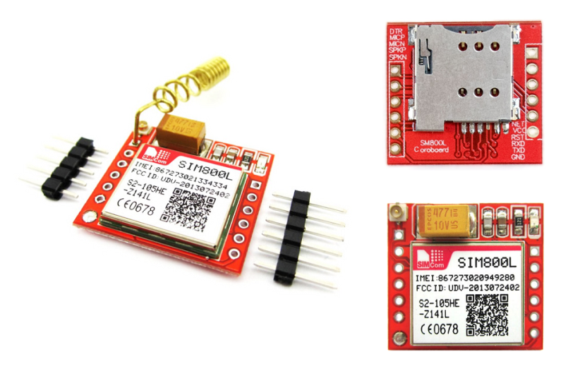

**Fig 4.14: GSM Modem**

* It requires a **SIM (Subscriber Identity Module)** card just like mobile phones to activate communication with the network. Also, they have **an IMEI** (International Mobile Equipment Identity) number similar to mobile phones for their identification. A GSM/GPRS MODEM can perform the following operations:

1.      Receive, send, or delete SMS messages in a SIM.

2.      Read, add, search phonebook entries of the SIM.

3.      Make, Receive, or reject a voice call.

* The MODEM needs **AT commands**, for interacting with processor or controller, which are communicated through serial communication. These commands are sent by the controller/processor. The MODEM sends back a result after it receives a command. Different AT commands supported by the MODEM can be sent by the processor/controller/computer to interact with the **GSM and GPRS cellular network**.

### ****4.7.4 GSM Architecture****

* The GSM architecture is divided into Radio Subsystem, Network and Switching Subsystem and the Operation Subsystem. Th e radio subsystem consists of the Mobile Station and Base Station Subsystem.
* The mobile station is generally the mobile phone which consists of a transceiver, display and a processor. Each handheld or portable mobile station consists of a unique identity stored in a module known as SIM (Subscriber Identity Chip).
* It is a small microchip which is inserted in the mobile phone and contains the database regarding the mobile station.

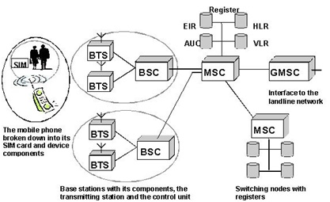

**Fig 4.15 : GSM Architecture**

**4.8 Moisture Sensor:**

* The soil moisture sensor is one [kind of sensor](https://www.elprocus.com/accelerometer-sensor-working-and-applications/) used to gauge the volumetric content of water within the soil. As the straight gravimetric dimension of soil moisture needs eliminating, drying, as well as sample weighting.
* These sensors measure the volumetric water content not directly with the help of some other rules of soil like dielectric constant, electrical resistance, otherwise interaction with neutrons, and replacement of the moisture content.
* The relation among the calculated property as well as moisture of soil should be adjusted & may change based on ecological factors like temperature, type of soil, otherwise electric conductivity.
* The microwave emission which is reflected can be influenced by the moisture of soil as well as mainly used in agriculture and remote sensing within hydrology.

### 4.8.1 Moisture Sensor Pin Configuration:

The FC-28 soil moisture sensor includes 4-pins.

## 

## Fig 4.16: Moisture Sensor

* This module also includes a potentiometer that will fix the threshold value, & the value can be evaluated by the [comparator-LM393](https://www.elprocus.com/lm393-ic-pin-configuration-circuit-diagram-and-its-working/). The [LED](https://www.elprocus.com/bipolar-led-driver-circuit-working-application/) will turn on/off based on the threshold value.

### 4.8.2 Working Principle

### This sensor mainly utilizes capacitance to gauge the water content of the soil (dielectric permittivity). The working of this sensor can be done by inserting this sensor into the earth and the status of the water content in the soil can be reported in the form of a percent.

* This sensor makes it perfect to execute experiments within science courses like environmental science, agricultural science, biology, soil science, botany, and horticulture.
* Specification: The specification of this sensor includes the following.

### The required voltage for working is 5V.

* The required current for working is <20mA.
* Type of interface is analog.
* The required working temperature of this sensor is 10°C~30°C.

## 

## 5.SOFTWARE REQUIREMENTS

* 1. **Arduino IDE:**

**Arduino IDE**where IDE stands for Integrated Development Environment – An official software introduced by Arduino.cc, that is mainly used for writing, compiling, and uploading the code in the Arduino Device. Almost all Arduino modules are compatible with this software that is an open source and is readily available to install and start compiling the code on the go.

**Introduction to Arduino IDE:**

* Arduino IDE is an open-source software that is mainly used for writing and compiling the code into the Arduino Module.
* It is an official Arduino software, making code compilation too easy that even a common person with no prior technical knowledge can get their feet wet with the learning process.
* It is easily available for operating systems like MAC, Windows, and Linux and runs on the Java Platform that comes with inbuilt functions and commands that play a vital role for debugging, editing, and compiling the code in the environment.
* A range of Arduino modules available including Arduino Uno, Arduino Mega, Arduino Leonardo, [Arduino Micro](https://www.theengineeringprojects.com/2018/09/introduction-to-arduino-micro.html) and many more.
* Each of them contains a microcontroller on the board that is programmed and accepts the information in the form of code.
* The main code, also known as a sketch, created on the IDE platform will ultimately generate a Hex File which is then transferred and uploaded in the controller on the board.
* The IDE environment mainly contains two basic parts: Editor and Compiler where former is used for writing the required code and later is used for compiling and uploading the code into the given Arduino Module.
* This environment supports both C and C++ languages.

How to install Arduino IDE:

You can download the Software from [Arduino](https://www.arduino.cc/en/Main/Software) main website. As I said earlier, the software is available for common operating systems like Linux, Windows, and MAX, so make sure you are downloading the correct software version that is easily compatible with your operating system.

* If you aim to download Windows app version, make sure you have Windows 8.1 or Windows 10, as app version is not compatible with Windows 7 or older version of this operating system.

The IDE environment is mainly distributed into three sections.

**1. Menu Bar**

**2. Text Editor**

**3. Output Pane**

As you download and open the IDE software, it will appear like an image below.

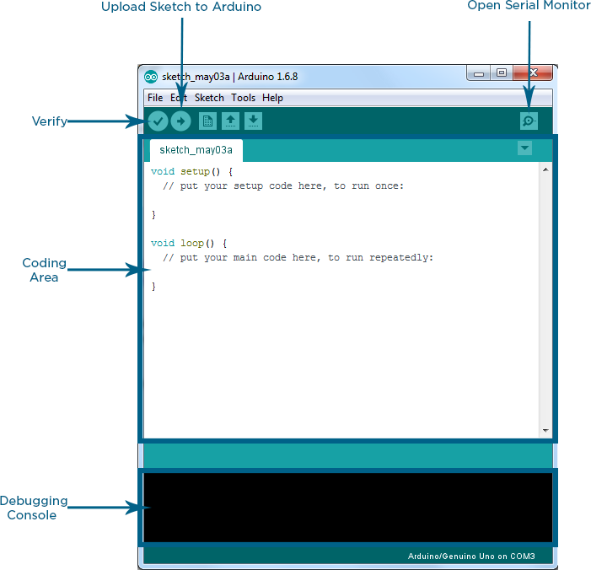

**Fig 5.1: IDE software**

The bar appearing on the top is called **Menu Bar** that comes with five different options as follow

* **File** – You can open a new window for writing the code or open an existing one. Following table shows the number of further subdivisions the file option is categorized into.

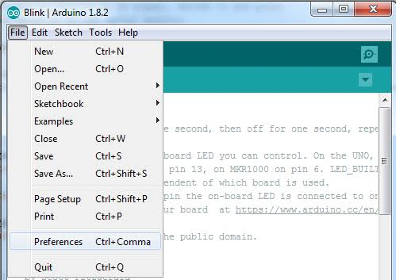

**Fig 5.2: IDE File**

As you go to the preference section and check the compilation section, the Output Pane will show the code compilation as you click the upload button.

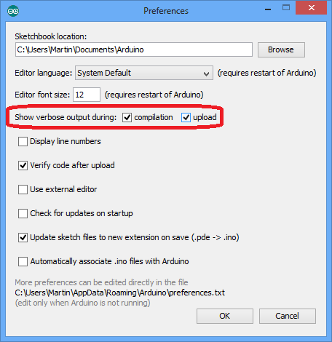

**Fig 5.3: Output File**

And at the end of compilation, it will show you the hex file it has generated for the recent sketch that will send to the Arduino Board for the specific task you aim to achieve.

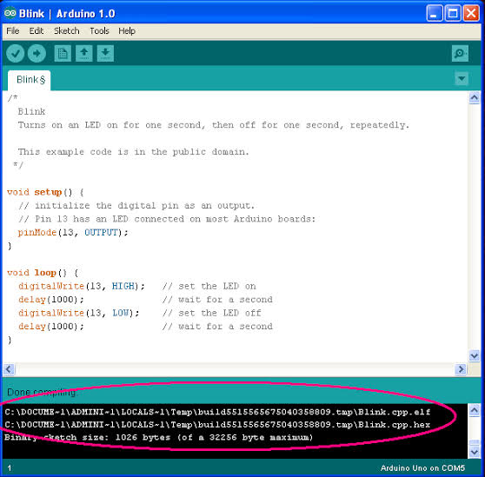

**Fig 5.4: HEX File**

* **Edit** – Used for copying and pasting the code with further modification for font
* **Sketch** – For compiling and programming
* **Tools** – Mainly used for testing projects. The Programmer section in this panel is used for burning a bootloader to the new microcontroller.
* **Help** – In case you are feeling skeptical about software, complete help is available from getting started to troubleshooting.

The **Six Buttons** appearing under the Menu tab relate to the running program as follow.

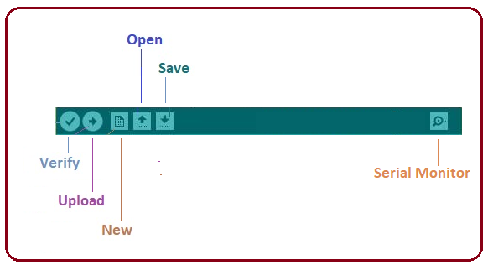

**Fig 5.5: Operating Button on Menu Tap**

* The check mark appearing in the circular button is used to verify the code. Click this once you have written your code.
* The arrow key will upload and transfer the required code to the Arduino board.
* The dotted paper is used for creating a new file.
* The upward arrow is reserved for opening an existing Arduino project.
* The downward arrow is used to save the current running code.
* The button appearing on the top right corner is a **Serial Monitor** – A separate pop-up window that acts as an independent terminal and plays a vital role for sending and receiving the Serial Data. You can also go to the Tools panel and select Serial Monitor or pressing Ctrl+Shift+M all at once will open it instantly. The Serial Monitor will help to debug the written Sketches where you can get a hold of how your program is operating. Your Arduino Module should be connected to your computer by USB cable to activate the Serial Monitor.
* You need to select the baud rate of the Arduino Board you are using right now. For my Arduino Uno Baud Rate is 9600, as you write the following code and click the Serial Monitor, the output will show as the image below.
* The main screen below the Menu bard is known as a simple text editor used for writing the required code.

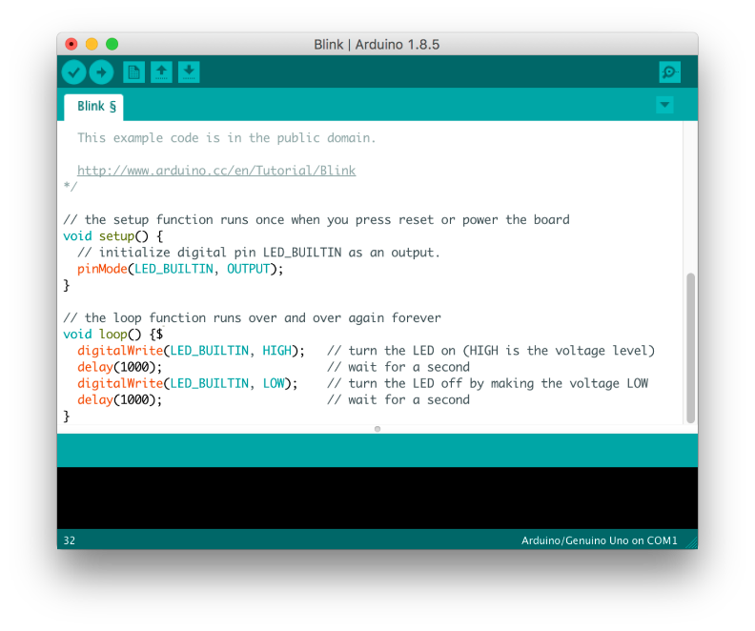

**Fig 5.6: Tex Editor**

* The bottom of the main screen is described as an Output Pane that mainly highlights the compilation status of the running code: the memory used by the code, and errors occurred in the program. You need to fix those errors before you intend to upload the hex file into your Arduino Module.

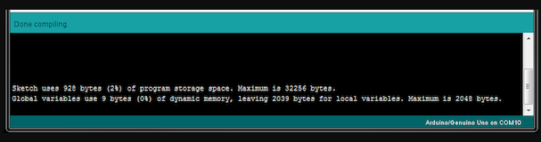

**Fig 5.7: Compiling**

* Arduino C language works similar to the regular C language used for any embedded system microcontroller, however, there are some dedicated libraries used for calling.

**5.1.1 Libraries:**

* Libraries are very useful for adding the extra functionality into the Arduino Module. There is a list of libraries you can add by clicking the Sketch button in the menu bar and going to Include Library.

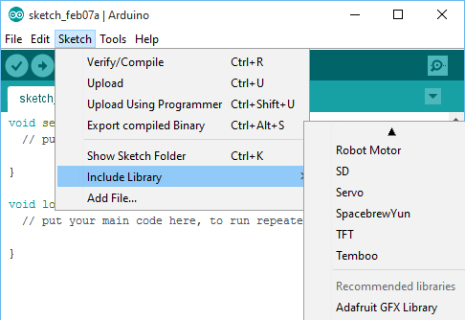

**Fig 5.8: Libraries**

* As you click the Include Library and Add the respective library it will on the top of the sketch with a #include sign. Suppose I Include the EEPROM library, it will appear on the text editor as

#include <EEPROM.h>.

* Most of the libraries are preinstalled and come with the Arduino software. However, you can also download them from the external sources.
  + 1. **Making pins Input and output:**
* The digital Read and digital Write commands are used for addressing and making the Arduino pins as an input and output respectively.
* These commands are text sensitive i.e., you need to write them down the exact way they are given like digital Write starting with small “d” and write with capital “W”. Writing it down with Digital write or digital write won’t be calling or addressing any function.

How to select the board:

To upload the sketch, you need to select the relevant board you are using and the ports for that operating system. As you click the Tools on the Menu, it will open like the figure below.  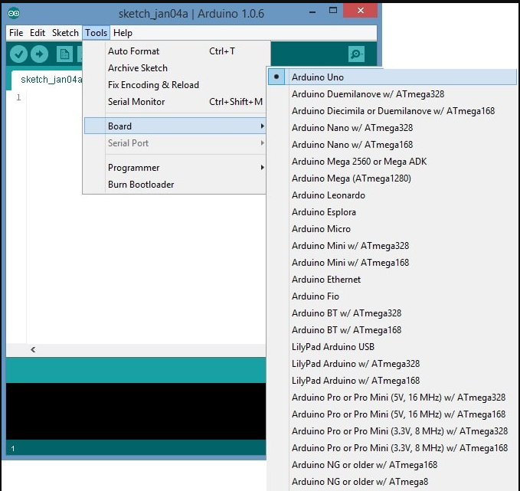

Fig 5.9: elect the board

* Just go to the “Board” section and select the board you aim to work on. Similarly, COM1, COM2, COM4, COM5, COM7 or higher are reserved for the serial and USB board. You can look for the USB serial device in the ports section of the Windows Device Manager.

Following figure shows the COM4 that I have used for my project, indicating the Arduino Uno with COM4 port at the right bottom corner of the screen.

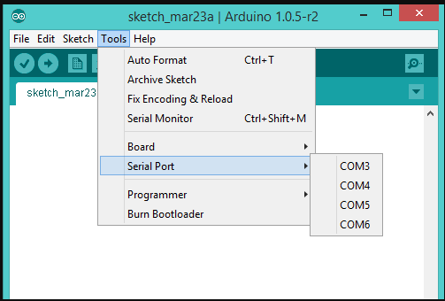

* After correct selection of both Board and Serial Port, click the verify and then upload button appearing in the upper left corner of the six-button section or you can go to the Sketch section and press verify/compile and then upload.
* The sketch is written in the text editor and is then saved with the file extension. It is important to note that the recent Arduino Modules will reset automatically as you compile and press the upload button the IDE software, however, older version may require the physical reset on the board.
* Once you upload the code, TX and RX LEDs will blink on the board, indicating the desired program is running successfully.

**Note**: The port selection criteria mentioned above is dedicated for Windows operating system only, you can check this [Guide](https://www.arduino.cc/en/Guide/Environment) if you are using MAC or Linux.

* The amazing thing about this software is that no prior arrangement or bulk of mess is required to install this software, you will be writing your first program within 2 minutes after the installation of the IDE environment.

**Bootloader:**

As you go to the Tools section, you will find a bootloader at the end. It is very helpful to burn the code directly into the controller, setting you free from buying the external burner to burn the required code.

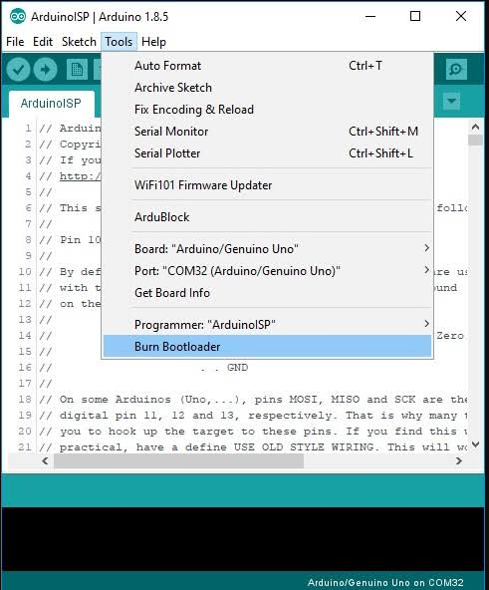

* When you buy the new Arduino Module, the bootloader is already installed inside the controller. However, if you intend to buy a controller and put in the Arduino module, you need to burn the bootloader again inside the controller by going to the Tools section and selecting the burn bootloader.

## Software Implementation :

* To aggregate, visualize and analyze live data streams in the cloud we use ThingSpeak which is an IOT analytics platform service. With the help of Thingspeak one can get visualizations of data posted by your devices to ThingSpeak.
* One can do online analysis and processing of data with the use of the ability of Thingpeak to code in MATLAB With the ability to execute MATLAB code in ThingSpeak .
* ThingSpeak is often used for prototyping and proof of concept IOT systems that require analytics. You can send data to ThingSpeak from your devices, create instant visualization of live data, and send alerts. Optionally, you can manage your data, and you can build your own front end for your clients and customers to log in to with Thingspeak.
* In an automated way Thingspeak charts the data that you send it, so you can remotely monitor yourdevices orequipment from anywhere. You can see your data from any web browser or mobile device. You can share read only views of your data with clients and peers that you need. At broad level many IOT systems can be described using the diagram below :

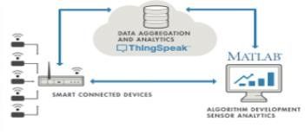

**Figure:** Block diagram of Thingspeak.

**ThingSpeak Features:**

One can aggregate, visualize, and analyze live data streams in the cloud with ThingSpeak. Few of the main capacities of ThingSpeak involve the ability to:

* Collect data in private channels.
* Share data with public channels.
* Events Scheduling
* Analyze and visualize your data with MATLAB.
* In an automated way process your data and message using services like Twilio or Twitter
* Visualize your sensor data in real-time.
* Aggregate data on-demand from third-party sources

**6.ADVANTAGES**

* Reduces human effort.
* Saves time and fuel consumption.
* Monitors the garbage bins and informs about the level of garbage collected in the garbage bins.
* To keep our Environment clean & green.
* The cost & effort are less in this system.

**7.APPLICATIONS**

* This project can also be used in the” SMART CITY”.
* This project is also helpful in the government project of “SWACHH BHARAT ABHIYAN”.
* Support Digital India
* Real time-based Monitoring waste collection
* It makes our system transparent between Municipal Corporation, Workers and public.

## 8.CIRCUIT DIAGRAM

**Fig 24: Design**

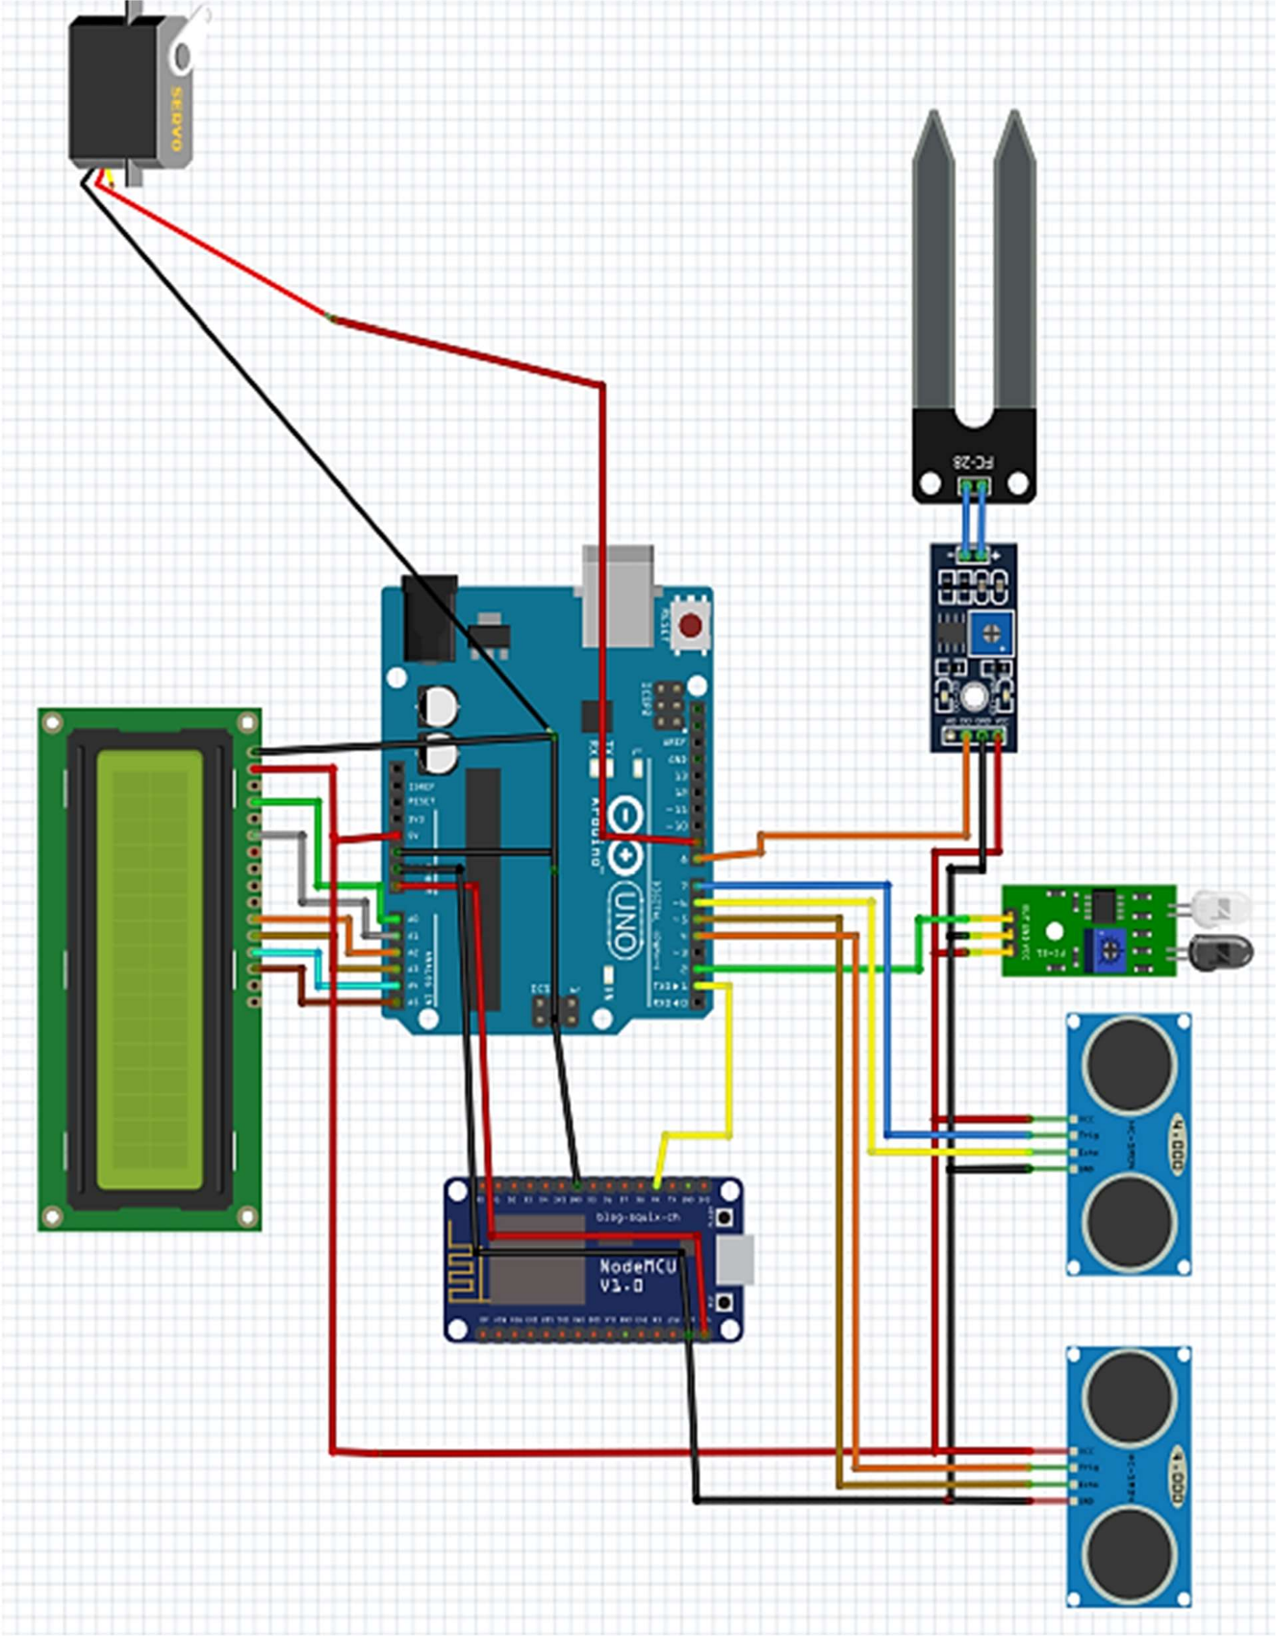

## 9.GRAPH ON WASTE MANAGEMENT

#### FROM 1960 -2021

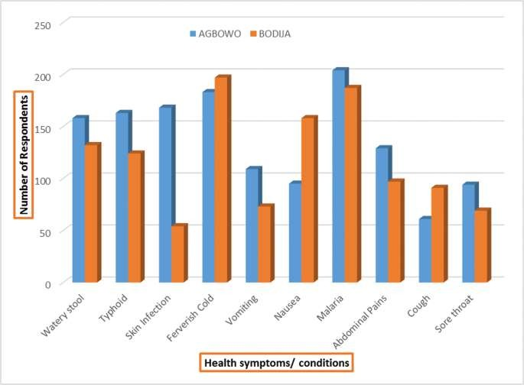

**Effects of Municipal Waste Disposal Methods on Community Health in Ibadan – Nigeria by the year 2017.**

**10.WORKING DIAGRAM**

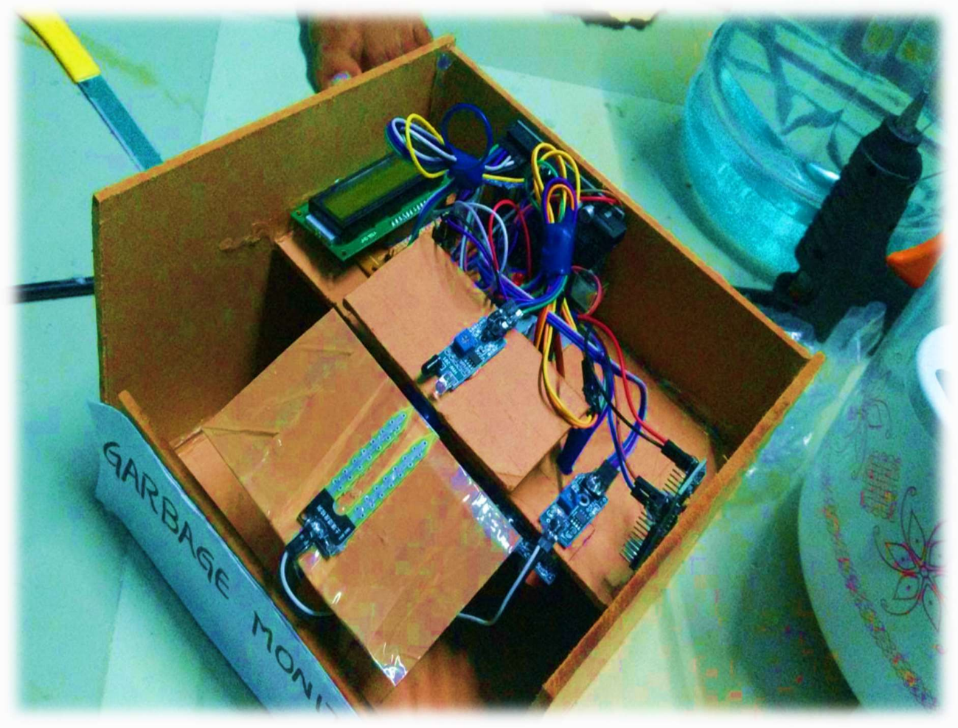

**WORKING MODEL IMAGE**

**Fig 25: WORKING MODEL**

* + We develop smart bins, and it is connected to the dashboard, and it can be accessed anywhere.
  + Our smart bins is implemented using IoT, cloud technology and data science. IoT is used for hardware progress on the devices and cloud is used for storing the data.
  + It introduces the design and implementation of garbage monitoring by measuring the garbage level in real time and to alert the municipality whenever the bin is full.
  + It separates or more precisely segregates the waste into two types, wet and dry waste, based on the moisture content present in the waste.

**11.RESULTS**

* The output of this project should have been the values of the distance, which we were supposed to get via a ThingSpeak Software. The proposed system uses a more powerful and efficient microcontroller, and the data is uploaded to the cloud when the sensor detected the threshold value.
* The data which is collected is stored in the cloud and can be used for predicting the waste generation. Automatic execution of commands and triggers help to supply apt values of the garbage levels resulting in better garbage collection.

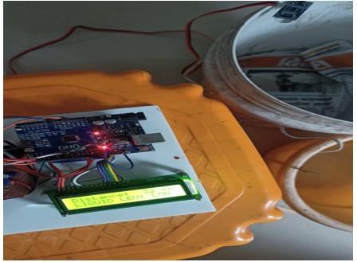

**Figure 11.1:** Empty Bin Output.

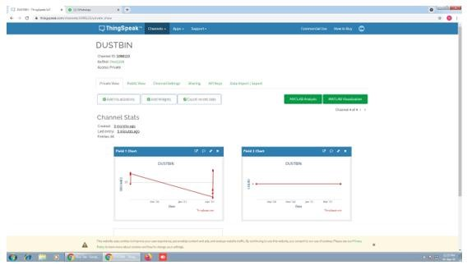

**Figure 11.1.1:** Result Analysis for Empty Bin.

* Waste Level detection inside the dustbin.
* Transmit the information wirelessly to local authorities.
* The data can be access anytime and from anywhere.
* The real time data transmission and access.
* Avoids the overflows of dustbins.

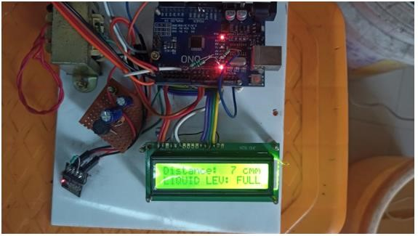

**Figure 11.2:** Result Analysis for Full bin.

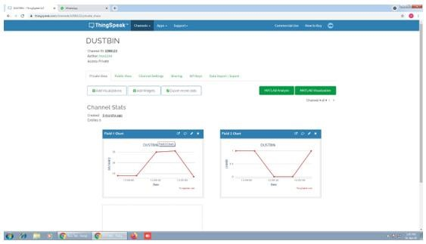

**Figure 11.2.1:** Result Analysis for Full bin using ThingSpeak.

The IP address which is received on the Serial Monitor is now placed into a web browser. The commands that were set up in the code will now be displayed as per the reading of the sensors.

* As shown, the sensor detects the dustbin being empty, hence the message conveying the same is displayed on the screen.
* In fig 11.1 shows the output of empty bin using all the equipment and show the level of the bin that is as the trash increases, the distance between the ultrasonic and the trash decreases. Hence the LCD shows the bin is empty.
* Figure 11.1.1 shows the result for empty bin using ThingSpeak software, here the graph plot against distance Vs time i.e., if the bin is empty then the graph shows the distance is 20cm for solid level. And if the bin is empty for liquid waste, then it shows the distance is ‘0’.
* Figure 11.2 shows the result analysis for full bin in this figure the LCD shows the distance i.e., the distance is 7cm in this we can conclude that if the distance is less than the bin is full and its gives trigger or alert signal to the municipal corporation office.
* the ThingSpeak reading is calculated for solid as well as liquid level here for solid state the distance is 8m and if we add some garbage on it then its level is increases and it gives alert signal.
* In the same way for liquid garbage monitoring if the distance is ‘1’ the bin is full then at that it gives alert signal to the controller and then process is continuing.

**12. CONCLUSION**

* The garbage system needs to be cleaned when it is filled to maintain a hygienic environment.
* Our smart garbage collection system contains a WIFI Module, Ultrasonic sensor, IR Sensor and Thing speak Cloud.
* The system monitors the garbage level, and it reaches the particular level it sends the notification.
* This notification system helps the municipality to monitor the garbage waste. If the garbage wastes are not cleaned it sends the message to higher authority.
* Our model overcomes the entire problem in smart garbage system monitoring.
* Reduces human effort.
* Saves time and fuel consumption.
* This bin data is also saved to a database for further analysis.
* The Novel cloud – based system for waste collection in smart cities.
* The developed system provides Improved database garbage collection time and quantity of garbage at each Location.
* By Implementing this project, we will avoid overflow garbage in residential area.
* Development of application for city Administration, Municipal staff…

## Future Scope

* The spread of internet is happening at a fast pace in every part of the world, which can digitize many aspects of day-to-day life.
* The scope from the project is that by providing knowledge of internet and its uses from people we can make village smart by providing these features like smart garbage management, digital water supply and intensity-controlled streetlight, etc.
* The garbage which is collected can be converted into compost using the traditional methods and new techniques.
* The proposed design of the smart garbage alert system is very flexible and can be easily installed at more crowded regions like airports, railway station, bus-stands, shopping malls, offices, etc.
* The government can setup recycling stations and the profit to be gained can be calculated.

**13. REFERENCES**

1. Prof. R.M.Sahu, Akshay Godase, Pramod Shinde, Reshma Shinde, “Garbage and Street Light Monitoring System Using Internet of Things” INTERNATIONAL JOURNAL OF INNOVATIVE RESEARCH IN ELECTRICAL, ELECTRONICS, INSTRUMENTATION AND CONTROL ENGINEERING, ISSN (Online) 2321 – 2004, Vol. 4, Issue 4, April 2016.
2. Kanchan Mahajan, Prof.J.S.Chitode, “Waste Bin Monitoring System Using Integrated Technologies”, International Journal of Innovative Research in Science, Engineering and Technology (An ISO 3297: 2007 Certified Organization) Vol. 3, Issue 7, July 2014.
3. Md. Shafiqul Islam, M.A. Hannan, Maher Arebey , Hasan Basri , “An Overview For Solid Waste Bin Monitoring System”, Journal of Applied Sciences Research, ISSN 181-544X, vol.5,lssue4, February 2012.

[4] Twinkle sinha, k.mugesh Kumar, p.saisharan, “SMART DUSTBIN”, International Journal of Industrial Electronics and Electrical Engineering, ISSN: 2347-6982 Volume-3, Issue-5, May2015.

[5] Richu Sam Alex, R Narciss Starbell, “Energy Efficient Intelligent Street Lighting System Using ZIGBEE and Sensors”, International Journal of Engineering and Advanced Technology (IJEAT) ISSN: 2249 – 8958, Volume-3, Issue-4, April 2014.

**ANNEXURE**

#include <LiquidCrystal.h>

#include <Servo.h>

Servo myservo; // create servo object to control a servo

LiquidCrystal lcd(A0, A1, A2, A3, A4, A5);

const int irPin = 6; // Connect IR sensor to digital pin A0

const int soilMoisturePin = 7; // Connect soil moisture sensor to digital pin A1

const int trigPin1 = 2; // Connect trig pin of first ultrasonic sensor to digital pin 2

const int echoPin1 = 3; // Connect echo pin of first ultrasonic sensor to digital pin 3

const int trigPin2 = 4; // Connect trig pin of second ultrasonic sensor to digital pin 4

const int echoPin2 = 5; // Connect echo pin of second ultrasonic sensor to digital pin 5

long duration1, duration2; // Variables to hold duration values for each ultrasonic sensor

float distance1, distance2; // Variables to hold calculated distances for each ultrasonic sensor

int irValue; // Initialize variable to hold IR sensor value

int soilMoistureValue; // Initialize variable to hold soil moisture sensor value

int count;

String msg;

void setup() {

Serial.begin(9600); // Initialize serial communication

pinMode(irPin, INPUT);

pinMode(soilMoisturePin, INPUT);

pinMode(trigPin1, OUTPUT); // Set trigger pin of first ultrasonic sensor as output

pinMode(echoPin1, INPUT); // Set echo pin of first ultrasonic sensor as input

pinMode(trigPin2, OUTPUT); // Set trigger pin of second ultrasonic sensor as output

pinMode(echoPin2, INPUT); // Set echo pin of second ultrasonic sensor as input

myservo.attach(9); // attaches the servo on pin 9 to the servo object

lcd.begin(16, 2);

// IOT Based Garbage Monitoring System And Domestic care

lcd.clear();

lcd.print("IOT Based Garbage");

lcd.setCursor(0,1);

lcd.print("Monitoring S/M");

delay(2000);

lcd.clear();

lcd.print("And Domestic");

lcd.setCursor(0,1);

lcd.print("Care");

delay(2000);

}

void loop() {

// Read value from IR sensor

count = 0;

myservo.write(90);

irValue = digitalRead(irPin);

// Read value from soil moisture sensor

soilMoistureValue = digitalRead(soilMoisturePin);

// Calculate distance for first ultrasonic sensor

digitalWrite(trigPin1, LOW);

delayMicroseconds(2);

digitalWrite(trigPin1, HIGH);

delayMicroseconds(10);

digitalWrite(trigPin1, LOW);

duration1 = pulseIn(echoPin1, HIGH);

distance1 = (duration1 / 2.0) * 0.0343; // Convert duration to distance in centimeters

// distance1 = map(distance1, 0, 1023, 1023, 0);

delay(500);

// Calculate distance for second ultrasonic sensor

digitalWrite(trigPin2, LOW);

delayMicroseconds(2);

digitalWrite(trigPin2, HIGH);

delayMicroseconds(10);

digitalWrite(trigPin2, LOW);

duration2 = pulseIn(echoPin2, HIGH);

distance2 = (duration2 / 2.0) * 0.0343; // Convert duration to distance in centimeters

// distance2 = map(distance2, 0, 1023, 1023, 0);

delay(500);

// Print sensor values to serial monitor

Serial.print("IR Sensor Value: ");

Serial.println(irValue);

if (irValue == 0) {

lcd.clear();

lcd.print("Dust Detected");

delay(2000);

count = 1;

}

Serial.print("Soil Moisture Sensor Value: ");

Serial.println(soilMoistureValue);

if (count == 1) {

lcd.clear();

lcd.print("checking");

lcd.setCursor(0, 1);

lcd.print("wet or dry");

delay(2000);

if (soilMoistureValue == 0) {

myservo.write(0);

lcd.clear();

lcd.print("adding to");

lcd.setCursor(0, 1);

lcd.print("wet bin");

delay(2000);

}

if (soilMoistureValue == 1) {

myservo.write(180);

lcd.clear();

lcd.print("adding to");

lcd.setCursor(0, 1);

lcd.print("dry bin");

delay(2000);

}

Serial.print("Distance from Ultrasonic Sensor 1: ");

Serial.print(distance1);

Serial.println(" cm");

Serial.print("Distance from Ultrasonic Sensor 2: ");

Serial.print(distance2);

Serial.println(" cm");

delay(500); // Wait for half a second before taking another reading

lcd.clear();

lcd.print("dustbin_1: ");

lcd.print(distance1);

lcd.setCursor(0, 1);

lcd.print("dustbin_2: ");

lcd.print(distance2);

delay(2000);

if (distance1 < 10) {

lcd.clear();

lcd.print("dustbin 1");

lcd.setCursor(0, 1);

lcd.print("is full");

msg = "-= Alert Message =- \n Dustbin-1 is full.";

delay(2000);

SendMessage();

}

if (distance2 < 10) {

lcd.clear();

lcd.print("dustbin 2");

lcd.setCursor(0, 1);

lcd.print("is full");

msg = "-= Alert Message =- \n Dustbin-2 is full.";

delay(2000);

SendMessage();

}

uploadgsm();

}

}

void uploadgsm() {

lcd.clear();

lcd.setCursor(0, 0);

lcd.print("preparing to ");

lcd.setCursor(0, 1);

lcd.print("send data....");

Serial.println("AT+CPIN?"); // sets the password of teh mobile device.

delay(1000);

Serial.println("AT+CREG?"); //Request network registration status

delay(1000);

Serial.println("AT+CGATT=1"); //Check for GPRS attachment service status

delay(1000);

Serial.println("AT+CIPSHUT"); //detach from GPRS networK

delay(1000);

Serial.println("AT+CIPSTATUS"); //current connection status

delay(2000);

Serial.println("AT+CIPMUX=0"); //used to single IPor multi-IP connection Simcom modules

delay(2000);

ShowSerialData();

Serial.println("AT+CSTT=\"airtelgprs.com\""); //start task and setting the APN,

delay(1000);

ShowSerialData();

Serial.println("AT+CIICR"); //bring up wireless connection

delay(3000);

ShowSerialData();

Serial.println("AT+CIFSR"); //get local IP adress

delay(2000);

ShowSerialData();

Serial.println("AT+CIPSPRT=0"); //setting prompt

delay(3000);

ShowSerialData();

lcd.clear();

lcd.setCursor(0, 0);

lcd.print("data sending...");

Serial.println("AT+CIPSTART=\"TCP\",\"api.thingspeak.com\",\"80\""); //start up the connection

delay(6000);

ShowSerialData();

Serial.println("AT+CIPSEND"); //begin send data to remote server

delay(4000);

ShowSerialData();

String str = "GET https://api.thingspeak.com/update?api_key=6M9A323WKC06SLA0&field1=" + String(distance1) + "&field2=" + String(distance2);

Serial.println(str);

Serial.println(str); //begin send data to remote server

lcd.clear();

lcd.setCursor(0, 0);

lcd.print("data sent");

delay(4000);

ShowSerialData();

Serial.println((char)26); //sending

delay(5000); //waitting for reply, important! the time is base on the condition of internet

Serial.println();

ShowSerialData();

Serial.println("AT+CIPSHUT"); //close the connection

delay(100);

ShowSerialData();

}

void ShowSerialData() {

while (Serial.available() != 0)

Serial.write(Serial.read());

delay(5000);

}

void SendMessage() {

lcd.clear();

lcd.setCursor(0, 0);

lcd.print("sending");

lcd.setCursor(0, 1);

lcd.print("message....");

delay(1000);

Serial.println("AT+CMGF=1");

delay(1000);

Serial.println("AT+CMGS=\"+917995652149\"\r");

delay(1000);

Serial.println(msg);

delay(100);

Serial.println((char)26);

delay(1000);

lcd.clear();

lcd.setCursor(0, 0);

lcd.print("message sent");

delay(1000);

}